



CLI Vending Machine Documentation CO1401 Introduction to Programming: (2019/2020)

Name: Nethmi Weeraman

IDNo: 3000149

Table of Contents:

* Table of figures
* Introduction
* Automated Vending Machine Requirement
* Solution Approach
* Design
* Implementation
* Testing
* Limitations
* Future Enhancements
* Conclusion

Table of Figures:

* Figure 1. Flowchart for Updating Items
* Figure 2. Functions
* Figure 3. Functions used in updating
* Figure 4. Structs
* Figure 5. Arrays
* Figure 6. Main Menu error handling
* Figure 7. More Main Menu error testing
* Figure 8. Selecting item error testing
* Figure 9. More selecting item error testing
* Figure 10. Quantity selection error testing
* Figure 11. More quantity selection error testing
* Figure 12. Select option error pathways
* Figure 13. Select option error pathways
* Figure 14. Select option error pathways
* Figure 15. Order more or not
* Figure 16. Order finished
* Figure 17. Test function
* Figure 18. Test function condition (1)
* Figure 19. Test function condition (2)
* Figure 20. Test function condition (3)

Introduction:

An automated vending machine is one that stores items, and provides it to customers after cash is inserted, without the need for any direct interaction with sellers or staff. Though, the first ever vending machine is recorded to be invented in the 1st century AD, by Heron of Alexandria to dispense holy water in temples, it’s concept was later used for various goods such as food and beverages to cars and lottery tickets (Bellis, 2019).

In this documentation, the undivided focus will be on a vending machine storing edibles. Using this type of machine, consumers can view the menu of items available and choose an item or multiple items to purchase and then insert cash accordingly to get the items. Operators can access the machine to add, update, and delete items within it.

Automated vending machine Requirement:

A program to manage an automatic vending machine is to be made. Multiple items are to be made available within it. Details such as the item name, category and price are to be stored.

Users can request for a particular snack by inserting money into the machine

The operator may use your program to add new items, modify item details such as the price, delete an item (quantity should be 0) or to update the stock (+/- quantity).

Additionally, it should be possible to view the value of total sales and the value of all items currently in the machine.

It is adequate to temporarily store all the data in the main memory.

The code should conform to readability and maintainability guidelines. The program should be tested with a suitable testing strategy and be documented.

Solution Approach:

The program is to be developed using C++;

The goal of the project is to create a simulated vending machine that stores,

1. Name of items
2. Category of items
3. Price of items
4. Quantity of items.

These must be stored in their own relevantly named arrays. For convenience’s sake, we may have larger array sizes than required by the current items held in the vending machine, instead of resizing it when the need arises (For instance, in the addition of items, as later mentioned).

Customers are to be able to request for an item and insert money to get it, however they will only be able to obtain the item if they can satisfy

the conditions of,

* Having selected buy mode
* Inputting valid item code
* Inputting valid item quantity
* Selecting to order more or not
* Not exiting to main menu before bill completion
* Having inserted adequate funds,

After this updates must be done to quantity of the item(s) bought. The quantity is deducted for relevant items and these items are to be seen deducted from the total stock. Moreover, the sale should be added to the total sales and deducted from the total value of items held in the vending machine.

Cart items, cart item’s quantity and cart elements’ index, balance cash (If any) and price of products purchased is to be reset after exiting to main menu, to create a new cycle for new customers.

In this new cycle, however, total value, total stock, purchased item’s stock and total sales will not be reset. This is because if it was, then it would be as if the previous sale did not take place.

To summarise, the variables to be affected are,

* Quantity of items
* Total stock
* Total sales
* Total value
* Balance (Resets)
* Cart items (Resets)
* Cart item’s quantity (Resets)
* Cart item’s prices (Resets)
* Cart element’s index (Resets)

Operator must be able to add items, update items, delete items and view stats from the vending machine items; For this, the operator must have a greater access privilege than the customers. This access is to be unlocked by a password known by them and not any other user. (For instance, the password ‘123’.)

*Adding:*

To add an item, the following conditions must be met,

* Last item must be found,

(This can be done by finding the point in which the items’ arrays have null or empty places. This empty array element’s index is found. This index becomes the new item’s index and the details of the new items are set to this index. Now when the arrays are to be looped, the last item is the one after the newly added item, since the one found previously is now occupied. This goes on and on as more items are added).

* Array must have space for more items.

*Updating:*

To update an item, we can assume and additionally do it in a two ways,

* Where we can choose to update only the stock of an item and,
* Where we can choose to update all the details of an item (In case of the producer, changing the name, price and so on of a particular product).

To update an item, the following conditions must be met,

* If updating only stock, we can make sure deleted items cannot get updated,

Since it would be unpractical to allow it.

(In updating all details, we can allow an item to replace and “update” the value of the deleted item. This allows for no space to be wasted within the vending machine.)

* In updating both ways, we must make sure array items that are the ‘last item’ (with null values in all the item detail arrays) and beyond, cannot be updated. This must be ensured because although it is possible to “update” them, it is more fitting to allow for them to be “added”.

*Deleting:*

To delete an item, we can assume and additionally do it in two ways,

* Where we can choose to delete items that are out of stock and,
* Where we can choose to delete items that could be both, out of stock or not (In case of the item being dubbed unsafe for consumption and need so need to pulled out and other reasons.)

To delete an item, the following conditions must be met,

* In deleting out of stock items, we must make sure items with more than zero quantity cannot be deleted. (We could choose to have a method that automatically deletes the zero item quantity items.)
* In deleting both ways, we should make sure null-valued items cannot be “deleted”, because they never existed in the first place.

*Adding, updating and deleting* could affect the variables of,

* Total sales
* Total value
* Total stock
* Along with specific items’ array effects (Quantity, Price, Name, Category)

*Viewing the status of the machine*

To view status, the following conditions must be met,

* Have calculated total sales, total value and total stock
* Select relevant option

None of the variables would be affected by it, since it would be including only the display of output.

Design:

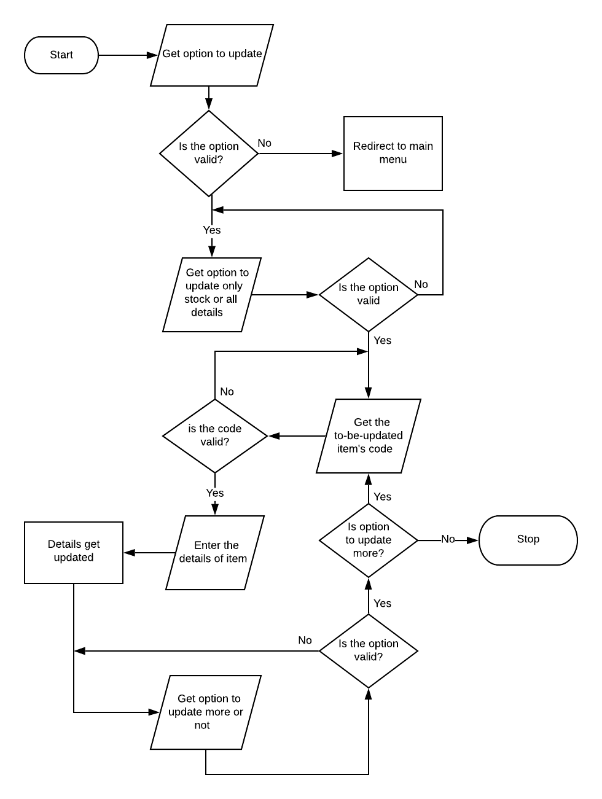Below is a flowchart detailing the process of updating the details of items;

Figure 1. Flowchart for Updating Items

Assumptions:

* Maximum capacity of 30 different items can be held in the vending machine.
* A customer cannot refrain from inserting money for purchase after they select finish order option.
* Users will not input string or decimal numbers into inputs that requires integers.
* Operator will not need to add items in bulk.
* Password for operator mode is ‘123’.

Implementation:

The code consists of,

* Functions
* Arrays
* Structs

Functions,

Functions allow for the program to be structured in a way where code can be divided into parts that serve to fulfil a purpose. Below the functions for the vending machine program are listed,

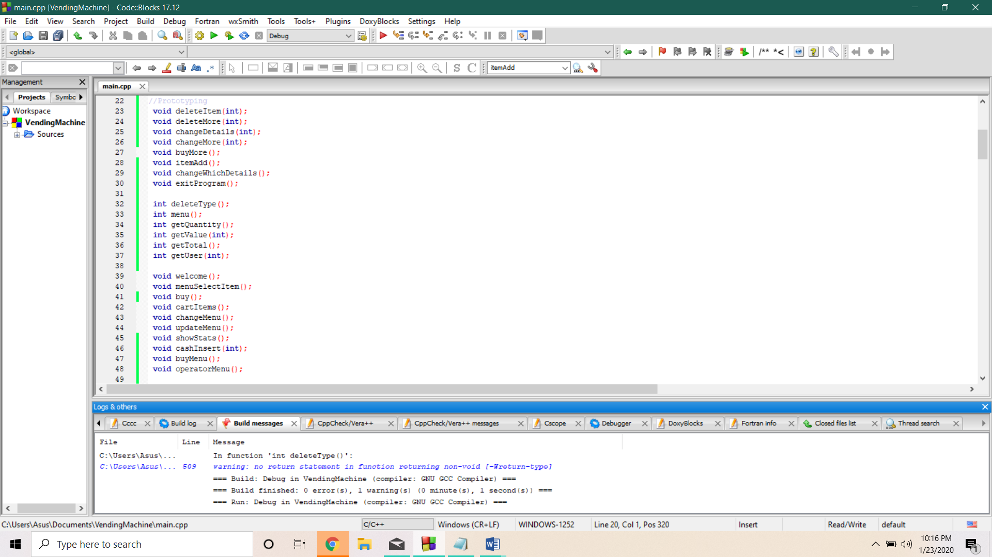

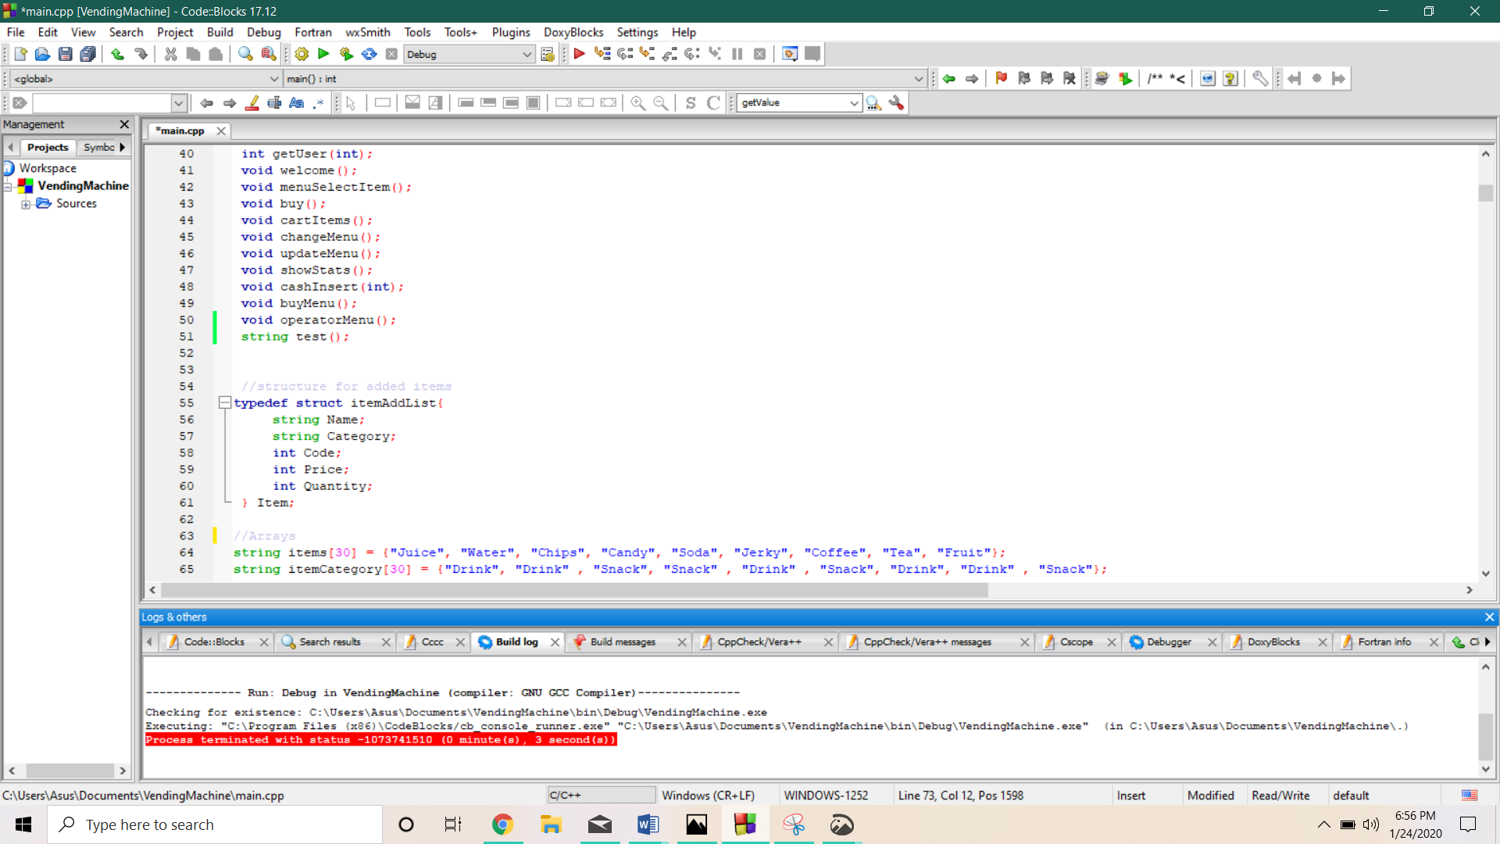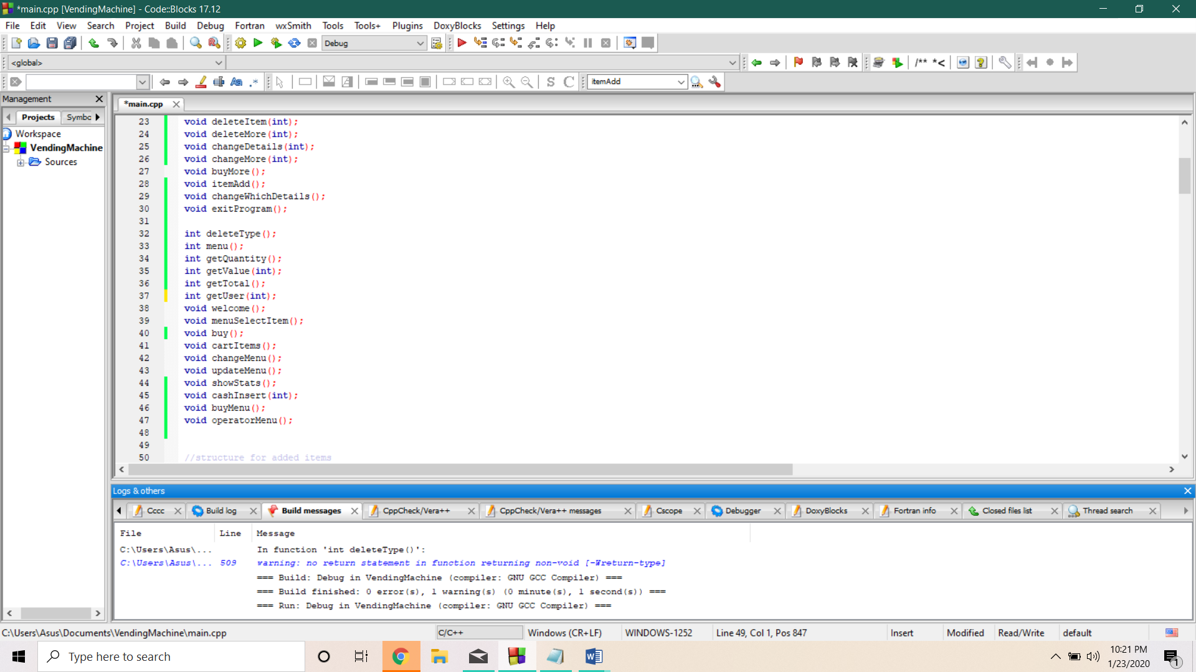

Figure 2. Functions

25 functions can be found in the list (24 after ‘test’ function is removed); The updating item side of the operator’s menu shown in the flowchart (Figure 1. Flowchart for Updating Items), is handled by the functions seen below.





Figure 3. Functions used in updating

These functions follow the same sequence of the flowchart representation in its implementation.

Structure,

Structures (structs) allow for data of different types to be held together. In the program code, there is one such structure.

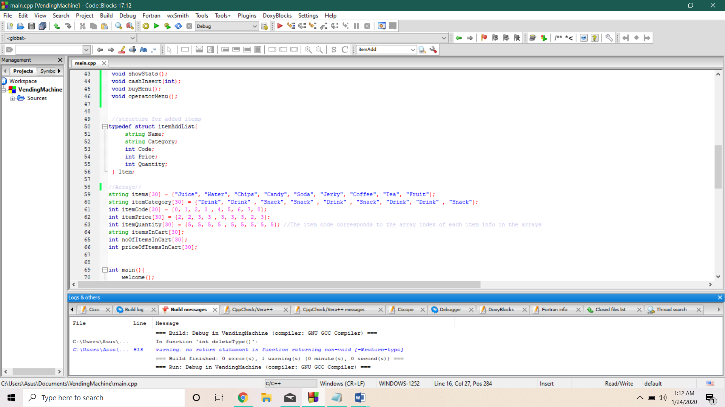

Figure 4. Structs

For this structure an object, (‘item’), is created. This object stores the values of the newest added item. This could be useful in case the most recent item needs to be tracked in future (There is no such function as of present but it is a possibility).

The item and its details are then added to the main arrays of items in the vending machine. (This could allow for validation of entered details for new item before it can be entered into arrays. For instance, if category of item is equivalent to ‘Snack’ or ‘Drink’ then it is added, otherwise it is rejected.)

Arrays,

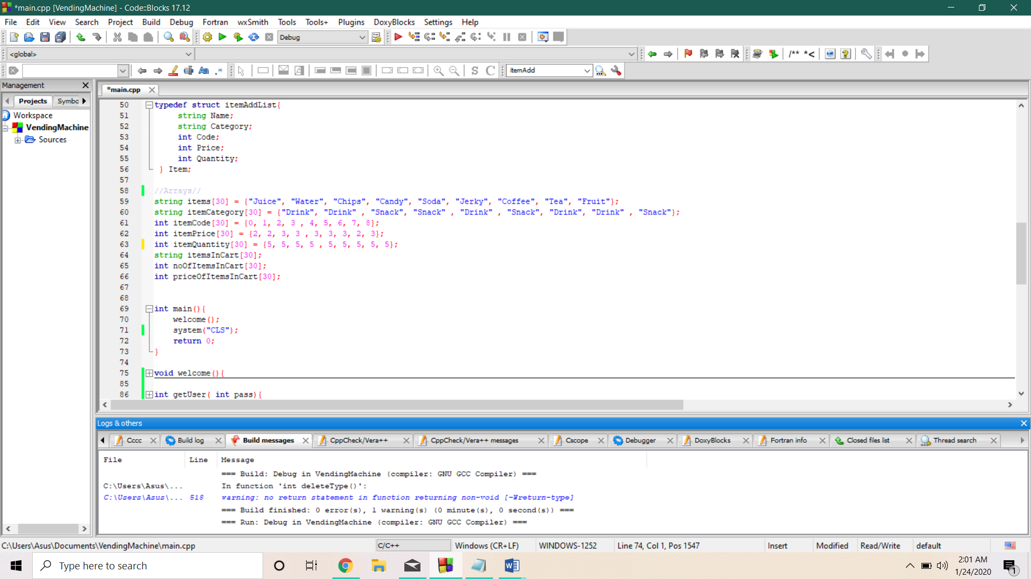Arrays allow for data of the same type to be stored together. There are 8 arrays within the program; As detailed below.

Figure 5. Arrays

The first 5 arrays handle the information of the vending machine items and its details. The other arrays, (‘itemsInCart’, ‘noOfItemsInCart’, ‘priceOfItemsInCart’), all handle the storage of items within a customer’s cart. These 3 arrays are reset after one customer purchases.

Testing:

System testing:

System testing is done by checking the finished product of code against all possible inputs and analysing the output, if it is the one desired or not. This type of testing concerns itself with how the user experiences the application. It is a black box testing method (Guru99, 2020).

Below, we will go through the system testing on the buy mode of the vending machine system and the possible error handling for incorrect input.

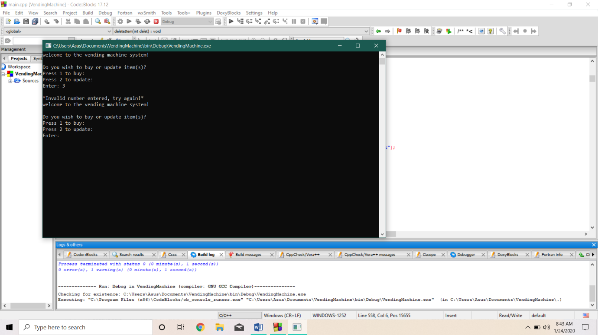Main menu testing against a not given option;

Figure 6. Main Menu error handling

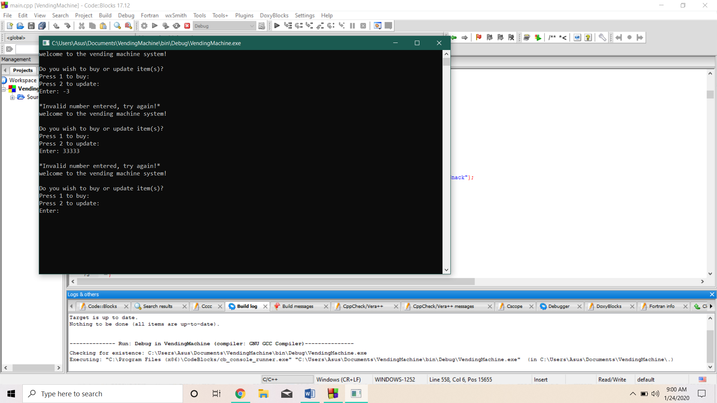Main menu testing against negative and larger not given option;

Figure 7. More Main Menu error testing

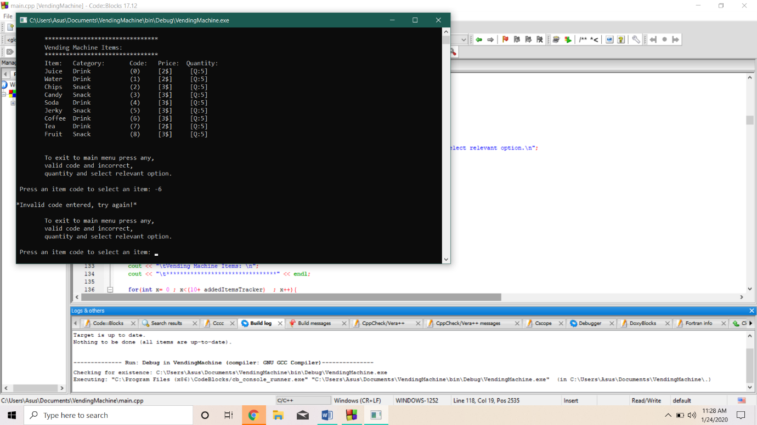Buy testing against not given options;

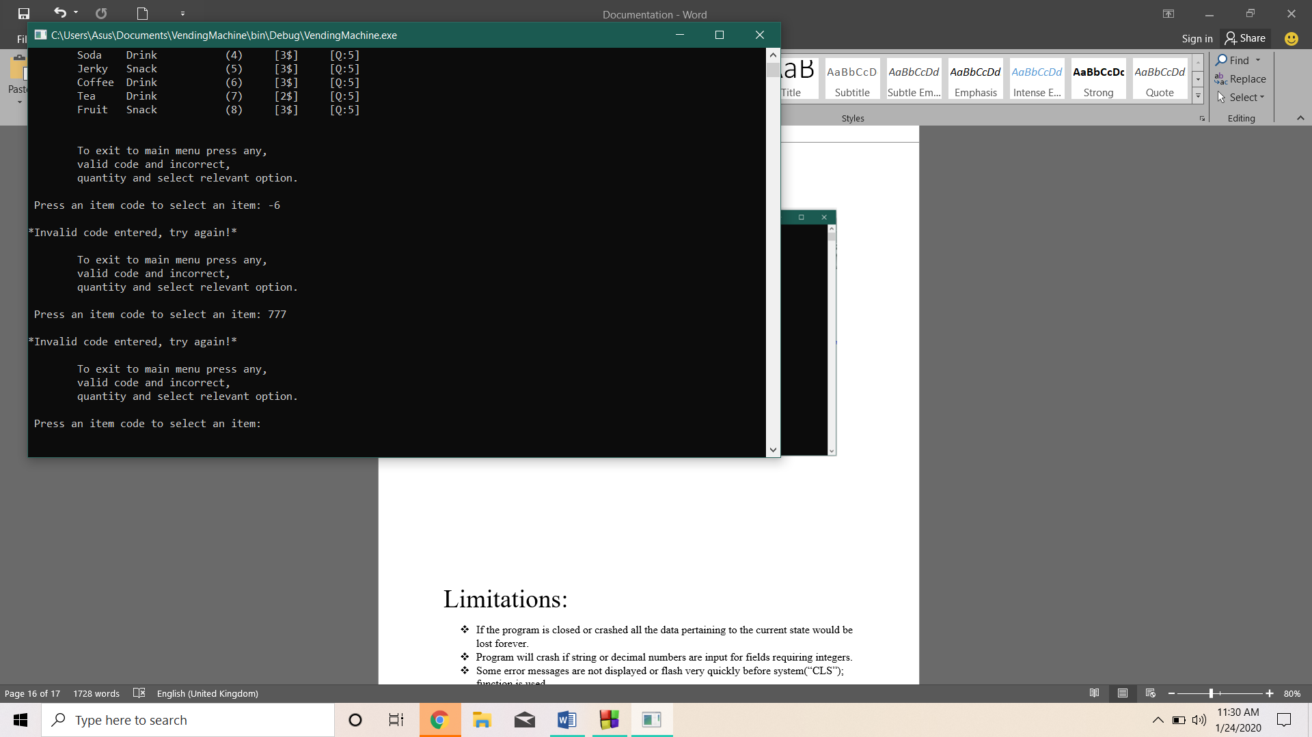Figure 8. Selecting item error testing

Figure 9. More selecting item error testing

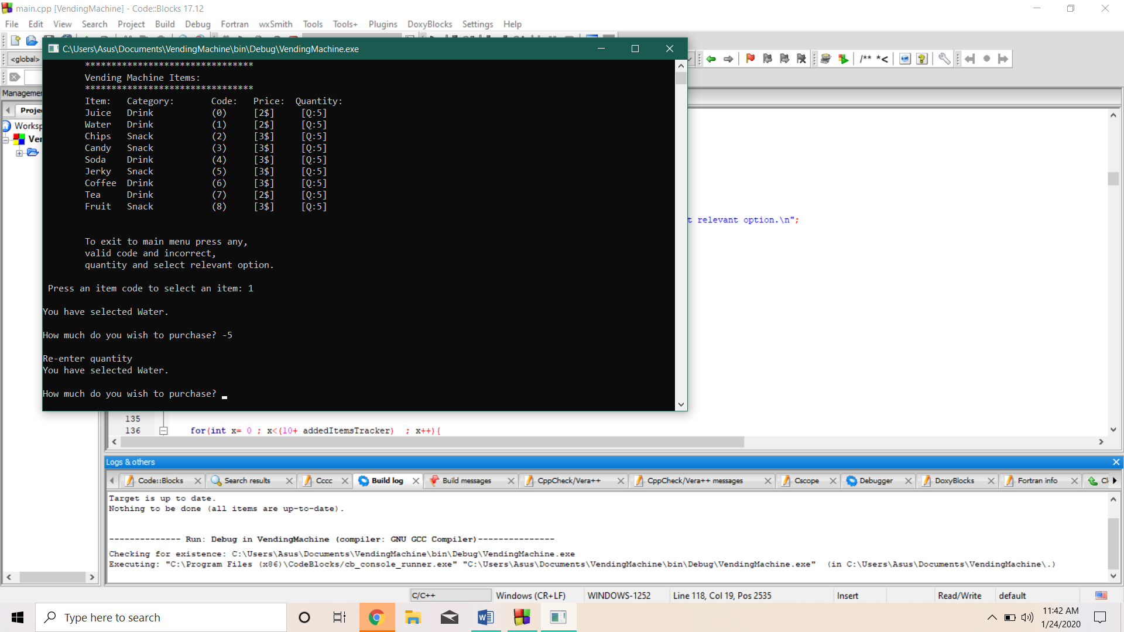Error testing on quantity selection;

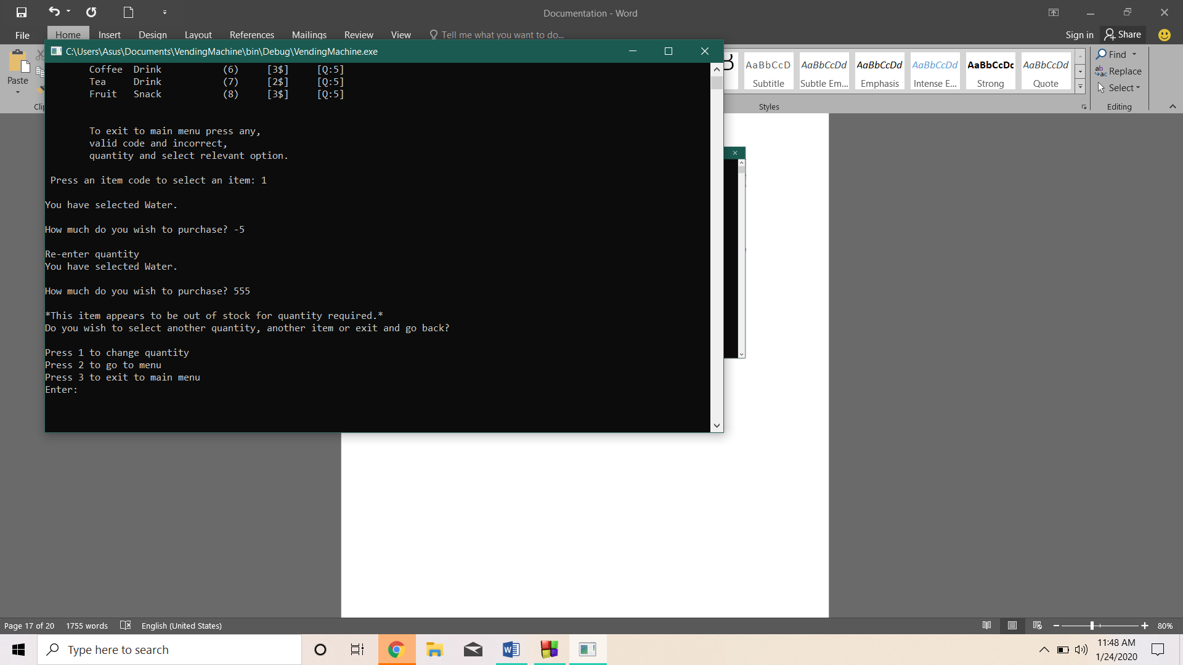Figure 10. Quantity selection error testing

Figure 11. More quantity selection error testing

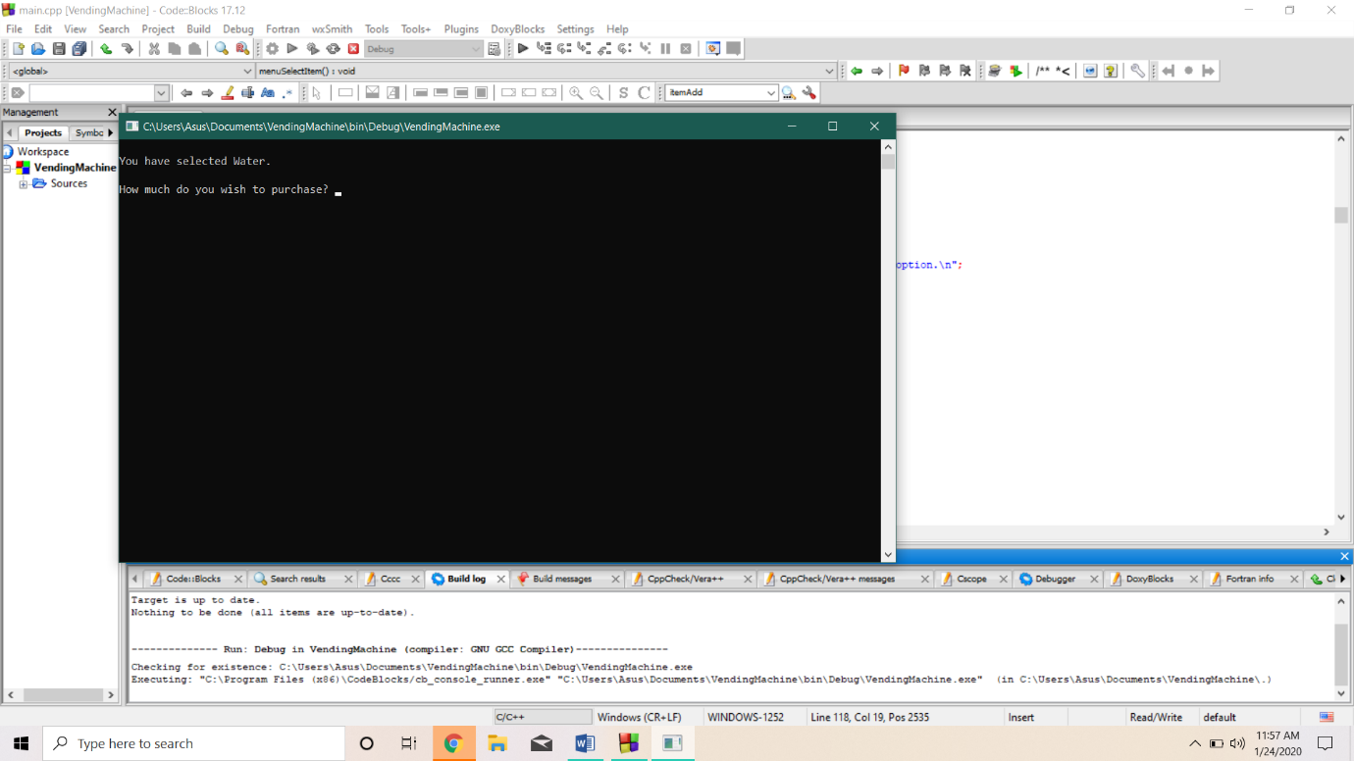When you press 1;

Figure 12. Select option error pathways

When you press 2;

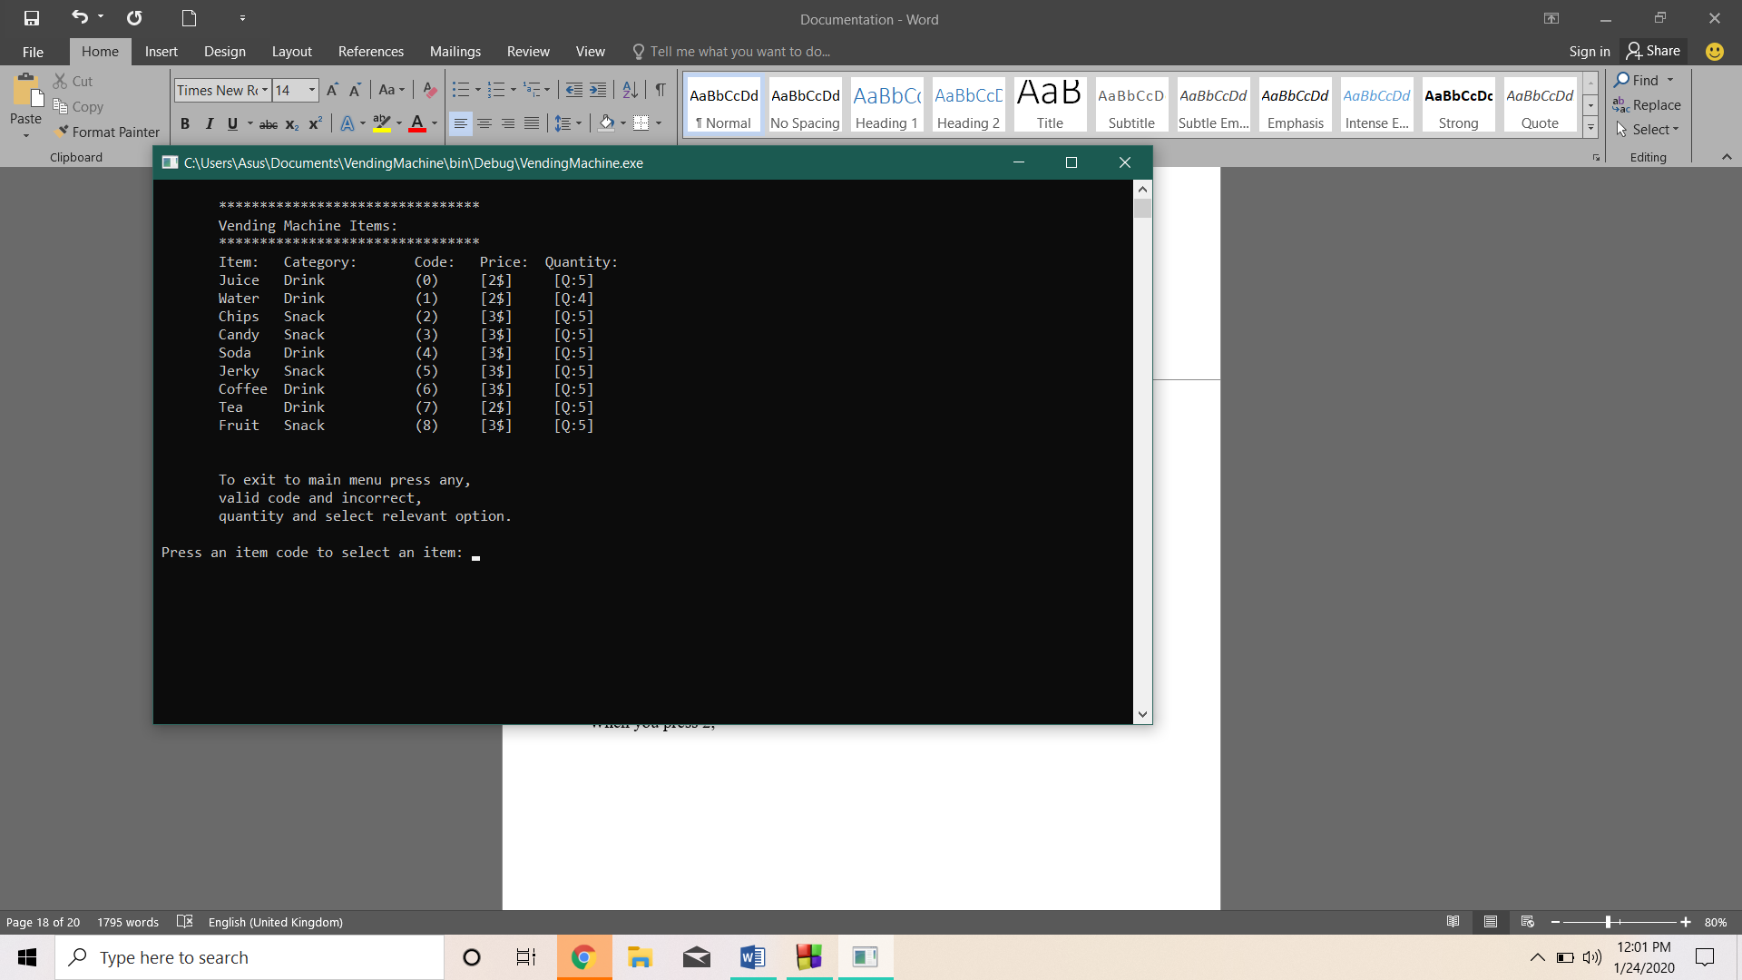Previous selected item is discarded and new item can be selected,

Figure 13. Select option error pathways

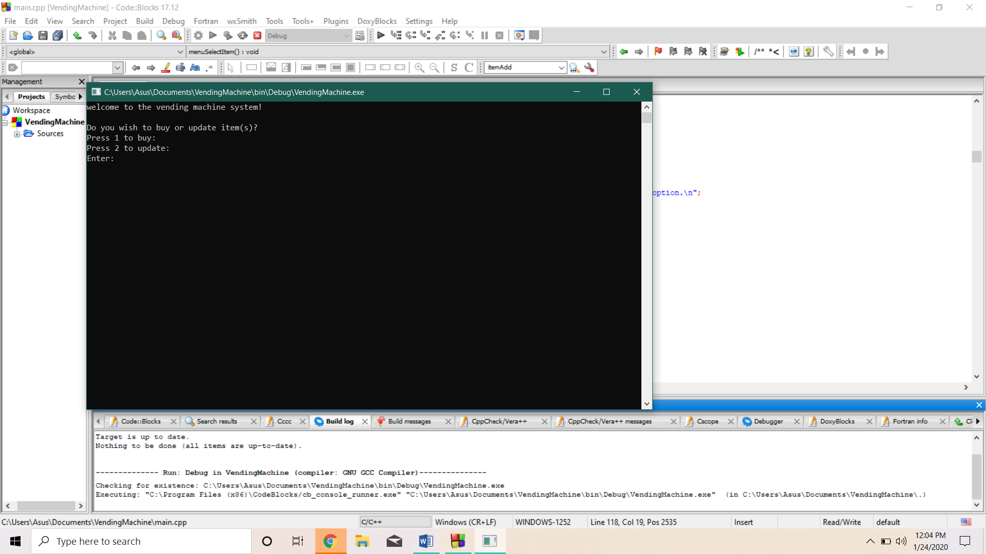When you press 3;

Figure 14. Select option error pathways

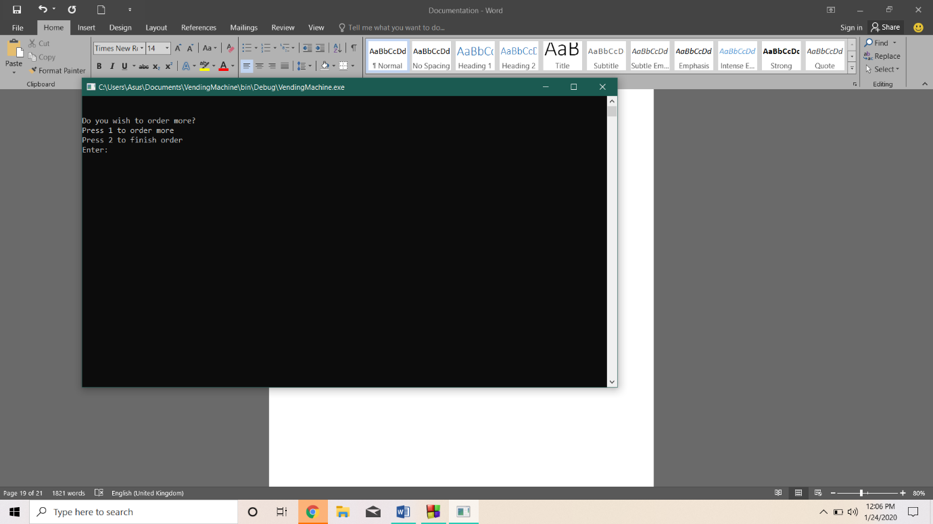If you select a proper item and quantity, you will see;

Figure 15. Order more or not

If you enter an invalid option here, it clears screen and loops the same question until a correct one is entered.

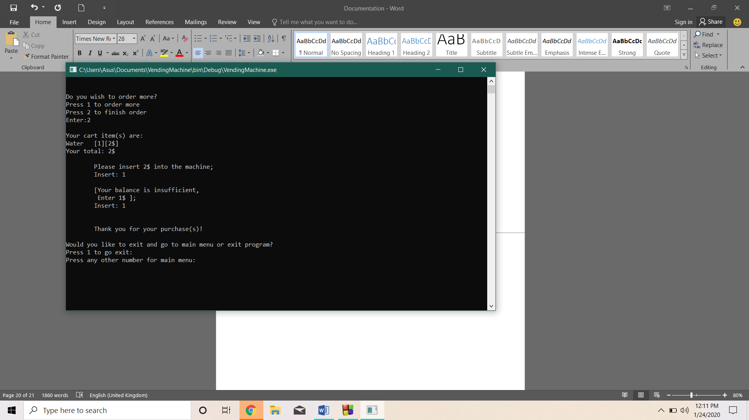

Figure 16. Order finished

Unit testing:

Unit testing is a white box testing method, that is used to check if functions use sound logic and get correct output in development. It focuses on the internal operations (Guru99, 2020). This program uses testing to see if some needed conditions are met. This is later removed.

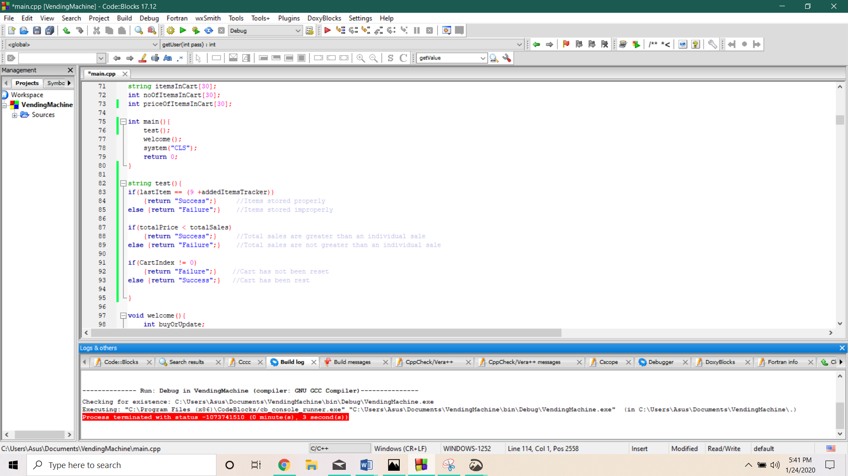

Figure 17. Test function

In the first condition, (‘if (lastItem == (9+addedItemsTracker)’), we can detect error in runtime, by inserting in ‘menu’ function.

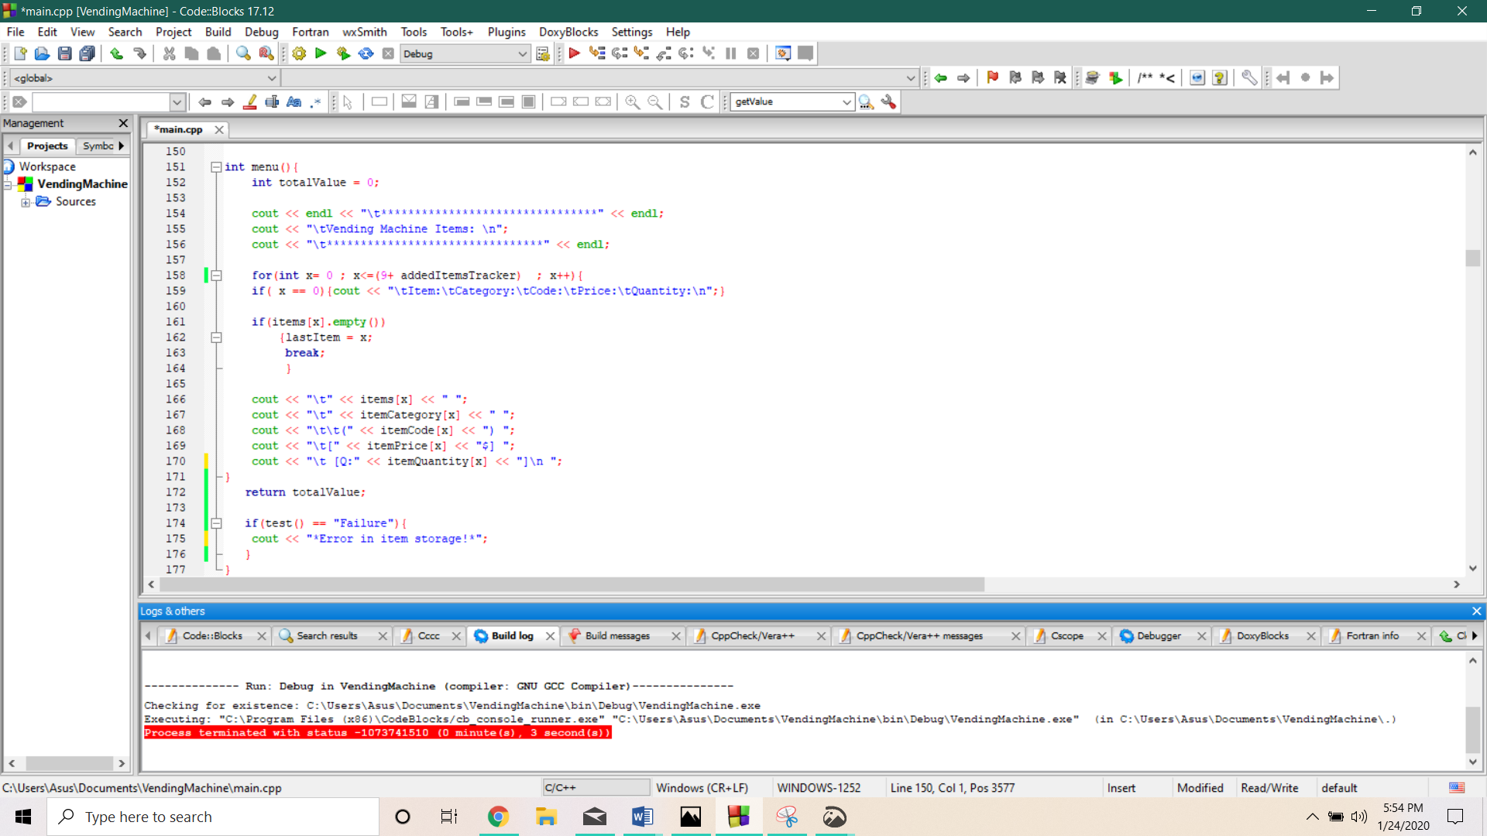

Figure 18. Test function condition (1)

In the second condition, (‘if(totalPrice < totalSales)’), we insert it into ‘buy’ function. (Note, below is only a snippet of ‘buy’ function.)

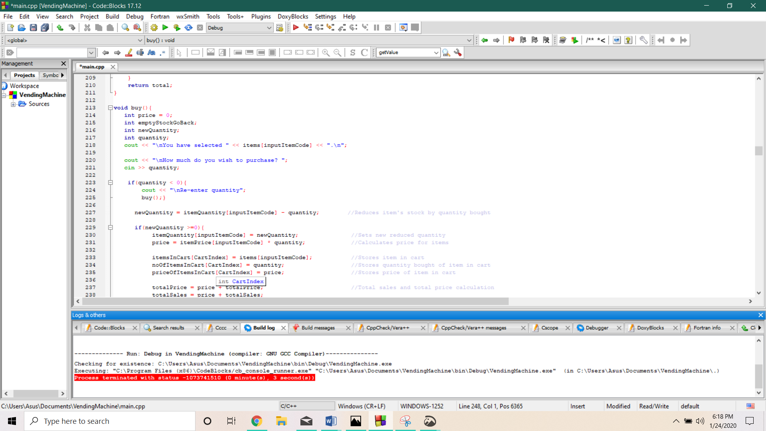

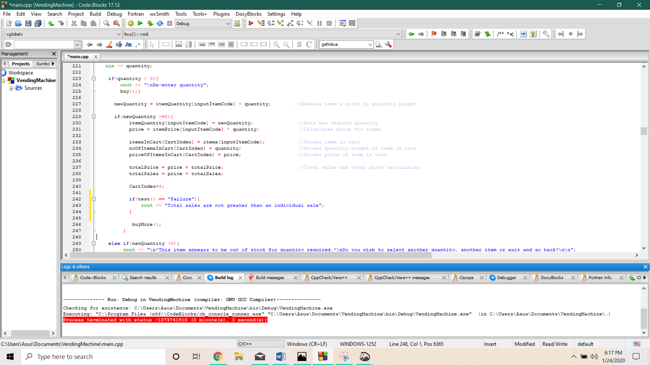

Figure 19. Test function condition (2)

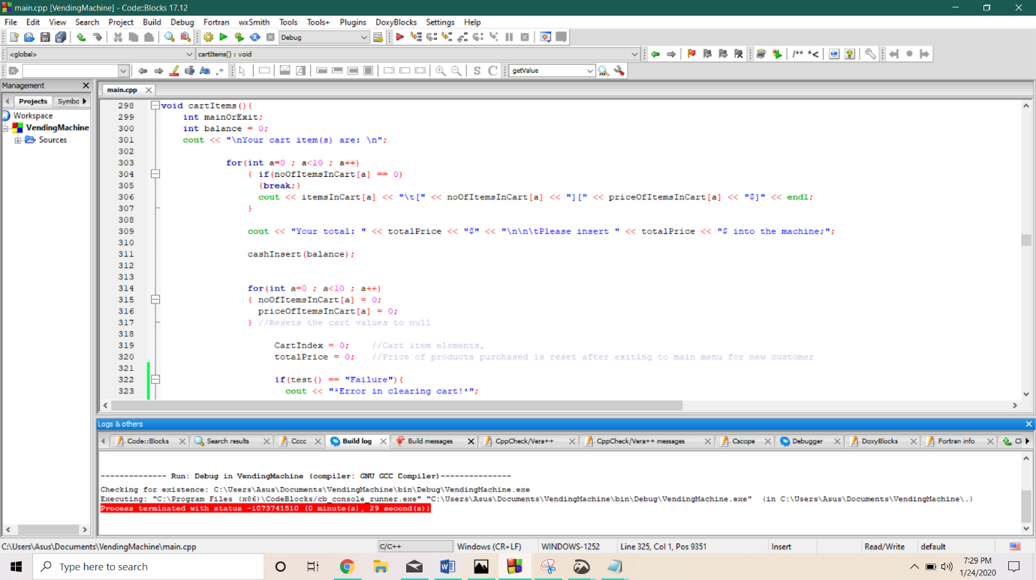In the third condition, (‘if (CartIndex != 0)’), we insert it into ‘cartItems’ function, to make sure each time a customer exits, the cart is reset in main menu. (Note, below is only a snippet of ‘cartItems’ function.

Figure 20. Test function condition (3)

Limitations:

* If the program is closed or crashed all the data pertaining to the current state would be lost forever.
* Program will crash if string or decimal numbers are input for fields requiring integers.
* Some error messages are not displayed or flash very quickly before system(“CLS”); function is used.
* Unit testing is used to check conditions, but not calculations.

Future Enhancements:

* isnumber() function could be used to stop the program crashing in case string/decimal is entered into integer fields.
* system(“PAUSE”); could be used before system(“CLS”) to allow certain error messages to be displayed.
* Adding items could be made to loop until terminated to allow for bulk additions of items.
* Track newest item and make sure new items are valid.
* Better unit testing system.

Conclusion:

The program is one to operate a vending machine system, it uses functions, structure, arrays along with variables and global variables to achieve this end.

References:

Bellis, M. (2019) *The History of Vending Machines* [Online].

Available from: https://www.thoughtco.com/the-history-of-vending-machines-1992599 (Accessed: January 22, 2020).

Guru99. (2020) *What is System Testing? Types & Definition with Example* [Online]. Available from: https://www.guru99.com/system-testing.html (Accessed: January 24, 2020).